**Experiment 4**

**Objective:**  WAP to N point DFT of user input sequence without using inbuilt function and plot its phase, magnitude spectrum and compute IDFT of the result obtained.

**Software used:** MATLAB 2016a

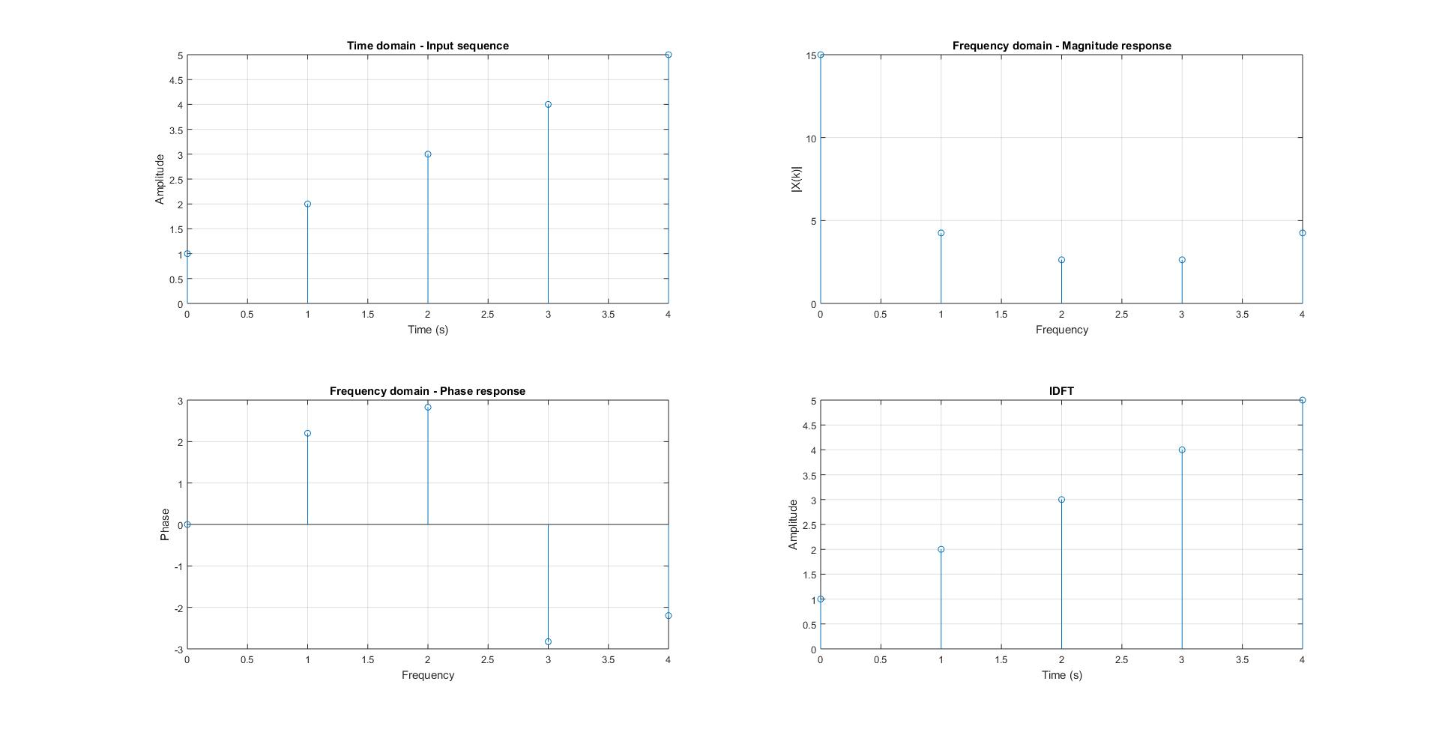

**Input :**

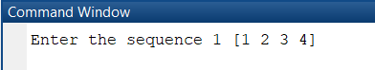

**Code:**

prompt = 'Enter the sequence 1 ';

x = input(prompt);

N = length(x);

X = zeros(N,1);

for k = 0:N-1

for n = 0:N-1

X(k+1) = X(k+1) + x(n+1)*exp(-j*2*pi*k*n/N);

end

end

t = 0:N-1;

subplot(221)

stem(t,x);

xlabel('Time (s)');

ylabel('Amplitude');

title('Time domain - Input sequence')

grid on

subplot(222)

stem(t,abs(X))

xlabel('Frequency');

ylabel('|X(k)|');

title('Frequency domain - Magnitude response')

grid on

subplot(223)

stem(t,angle(X))

xlabel('Frequency');

ylabel('Phase');

title('Frequency domain - Phase response')

grid on

dft = fft(x);

N1 = length(X)

X1 = zeros(1,N1);

for k = 0:N1-1

for n = 0:N1-1

X1(k+1) = (X1(k+1) + (1/N1)*X(n+1)*exp(1j*2*pi*k*n/N1));

end

end

ifft = ifft(X);

subplot(224)

stem(t,X1);

xlabel('Time (s)');

ylabel('Amplitude');

title('IDFT')

grid on